LAB 321Assignment | Type: | LongAssignment
 | Code: | J3.L.P0021
 | LOC: | 800
 | Slot(s): | 15

Title: Maria and Paul's Wedding
Background

You want to share your wedding party information to all your friend.
Complete this assignment to know how to write a wedding blog.
Reference site:http://www.simplesite.com/us-123wedding

Program Specifications

Program a web site to introduce your wedding party, detail functions of this website is described below

Features:
This website contains 5 main functions
- Function 1 : Home page : ( see PIC 01)
  - Display all entries sorted by published date
  - Each entries contains
    - Entry name
    - Entry Icon
    - Description picture
    - Entry description
- Function 2 : Photo album ( PIC 02)
  - Display all available photo
- Function 3 : Wishes list: ( PIC 03)
  - Display the wishes
- Function 4 : Guest book
  - Help guests to submit their message , their wishes
- Function 5 : party address
  - Display contact and location of party address

You do not need to write interface for admin control panel, you can add data manually (use SQL SERVER Management studio).
Note: All data must be load from database, not hard code in page.

Expectation of User interface:
Pic 01 : Home Page
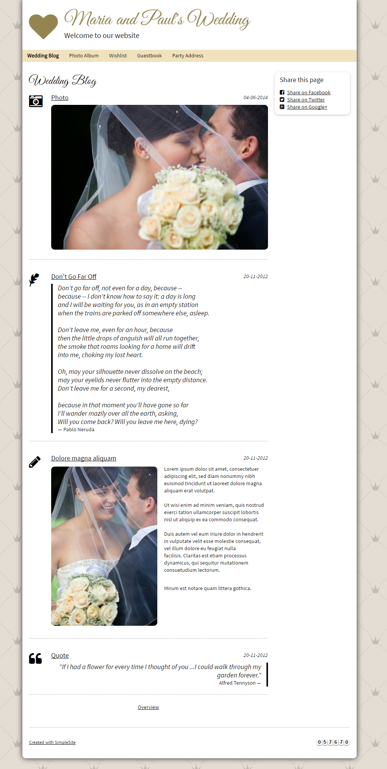
PIC 02 : When click to overview, system display all entries in short titles
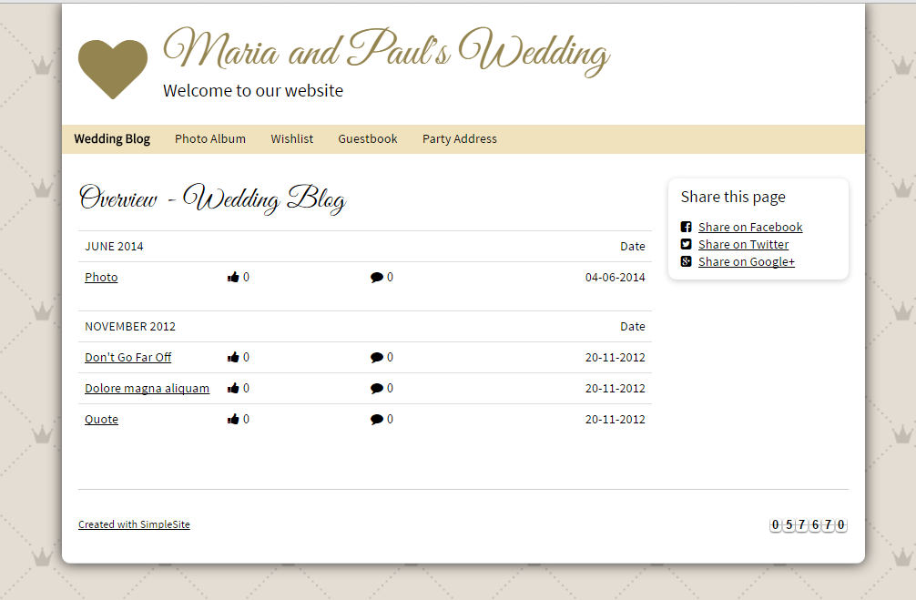
PIC 03 : Display photo album

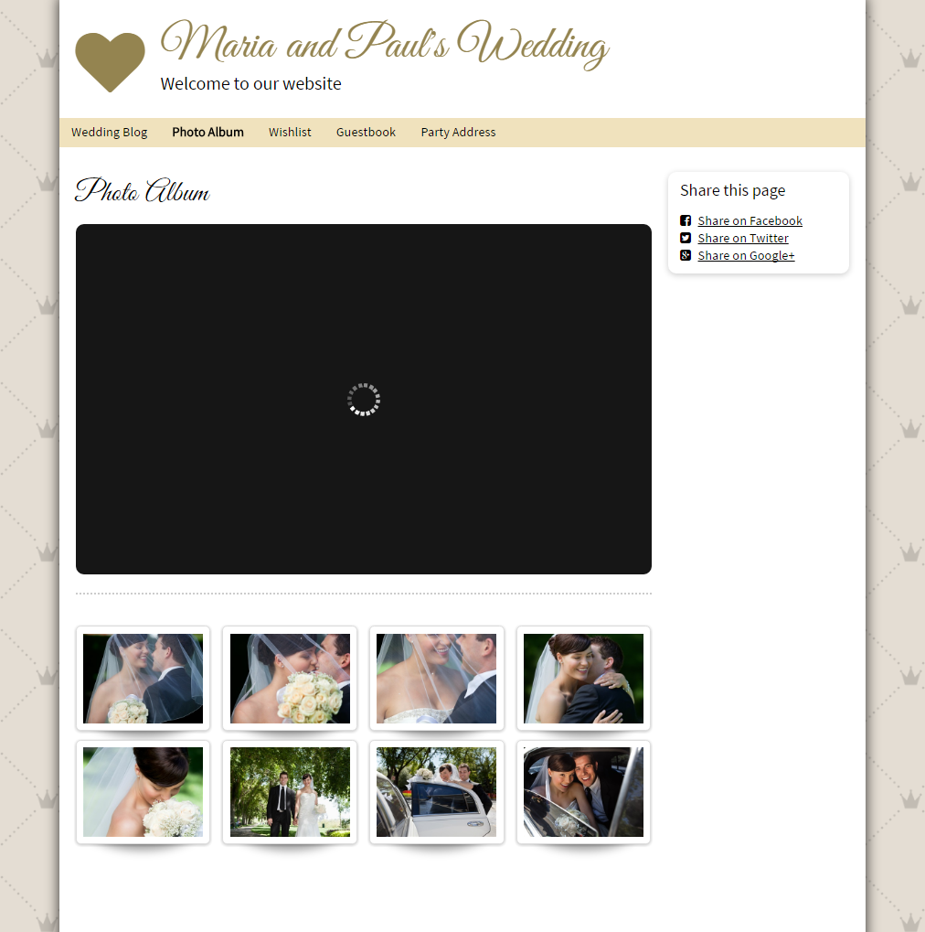
PIC 04 : Display all wishlist

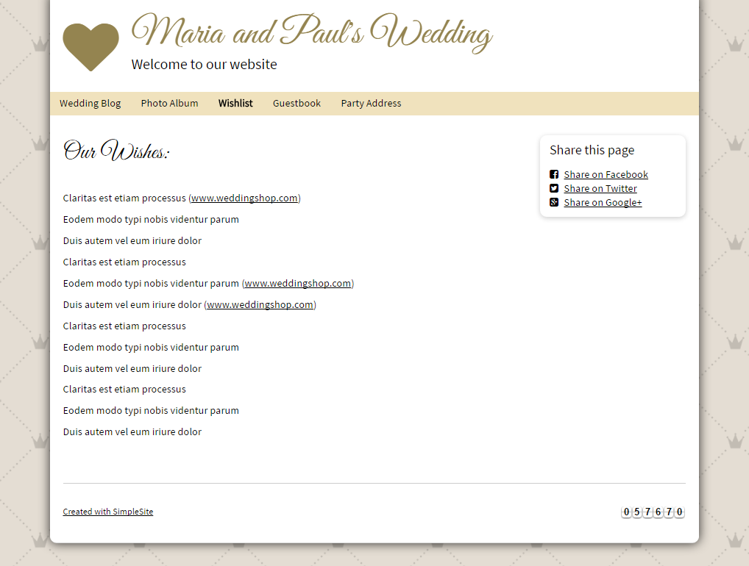
PIC 05 : Display guestbook

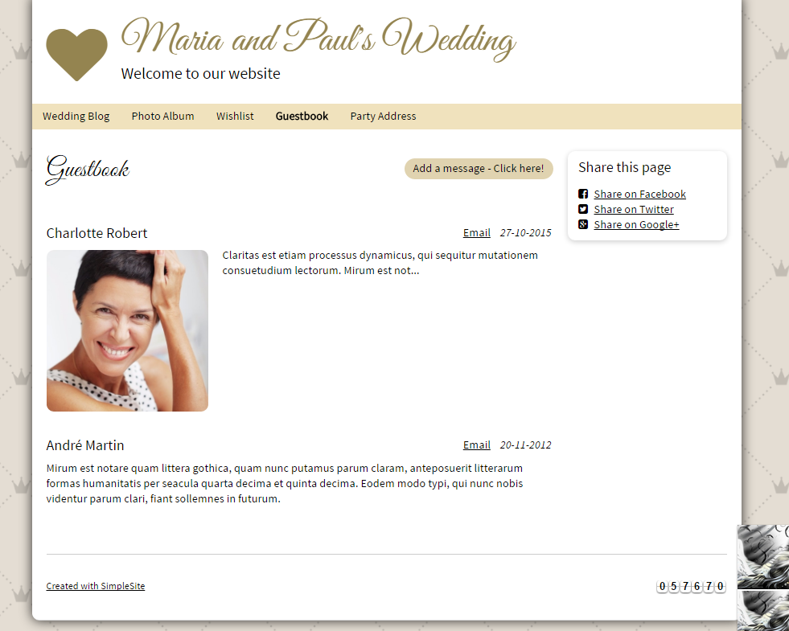
PIC 06 : Guest book – Add Message function

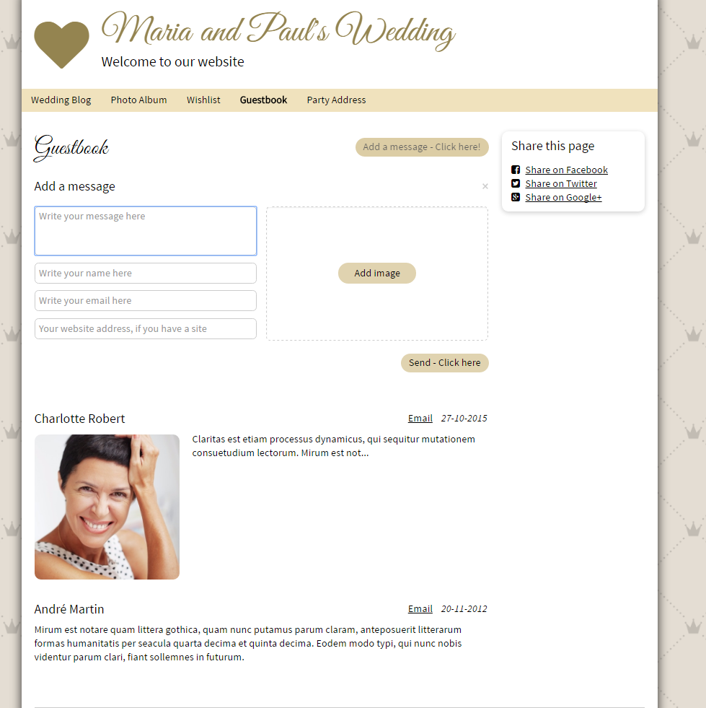
PIC 07 : Display party address

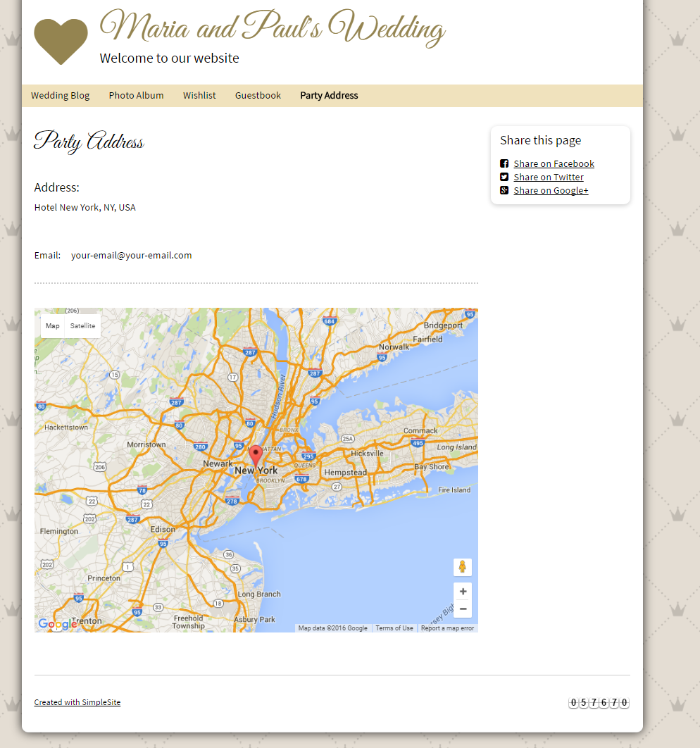
Guidelines
- Step 1 : Clarify requirement and scope with mentor
- Step 2 : Create prototype
- Step 3 : Design database base on created prototype
- Step 4 : Code & Test

